# Download or Update the Microsoft Whiteboard App

1. <http://aka.ms/whiteboardapp>
2. Login to the Microsoft Whiteboard App using your coach credentials.

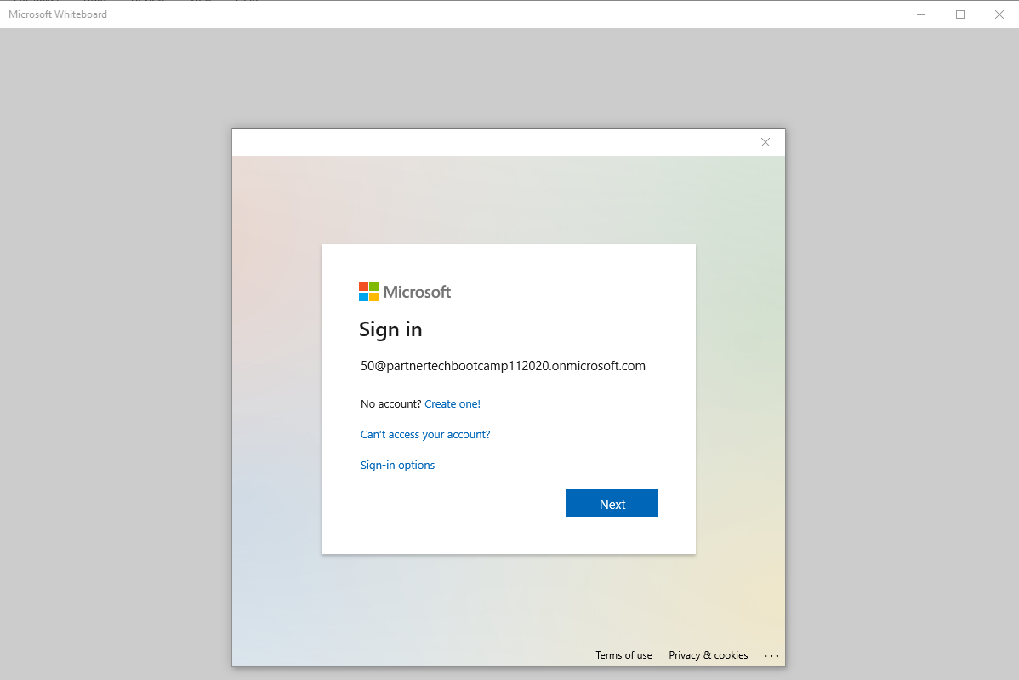

1. Quick tutorial for using the Whiteboard App

<https://www.youtube.com/watch?v=LCdC_ZjHvyU>

# Setting up the Whiteboard for your Team(s)

Each whiteboard design session will have its own unique team with the same name and a private channel and team meeting for each Team participating.

1. Join the meeting for the virtual table(s) you are responsible for and open the Team meeting from Team for your Whiteboard -> General -> View Groups tab in Teams.

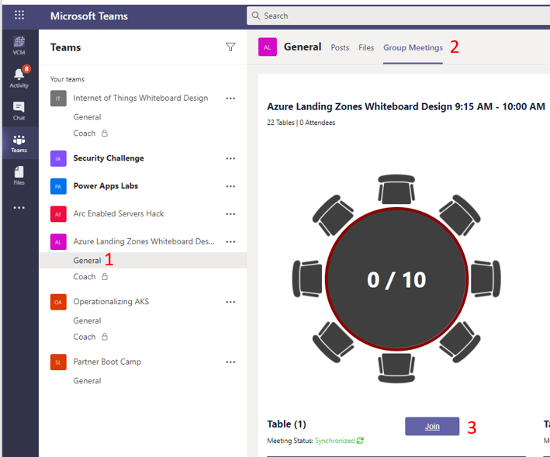

1. From within the Microsoft whiteboard app click the <- to create a new whiteboard.

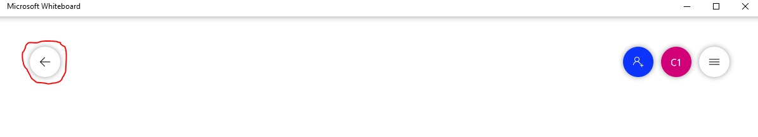

1. To create a registration link that attendees from your table can join click the Blue + button (below).

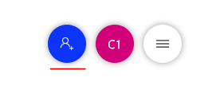

1. Then click the **…**

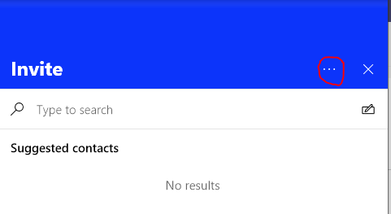

Then click **Create sharing link**

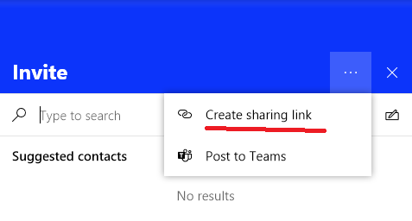

Click the **Web sharing link on** button and copy the generated link.

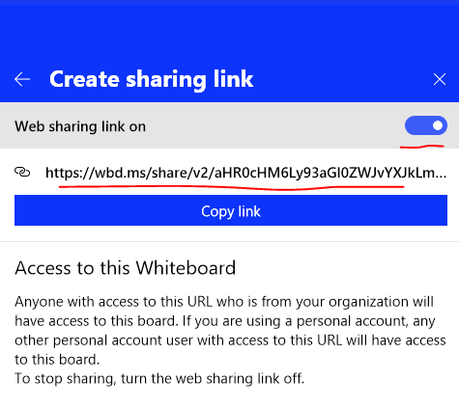

1. Back in your Team meeting paste the link into chat and using voice explain to attendees how to join the whiteboard (click the link).
2. Follow the coaches/trainer guide for your Whiteboard Design and explain to the participants what they are supposed to do.

# Coaching

Check-in on the progress of your team’s whiteboard design session. You want to try your best to get the whole team to engage to get the most value out of the whiteboard design.

# Present back

After your team has completed the whiteboard design, ask them to present back their solution to you where you are asking them questions from the perspective of the customer.